Page 1 — Create the VPC
Topic: VPC creation and IPv4 CIDR configuration
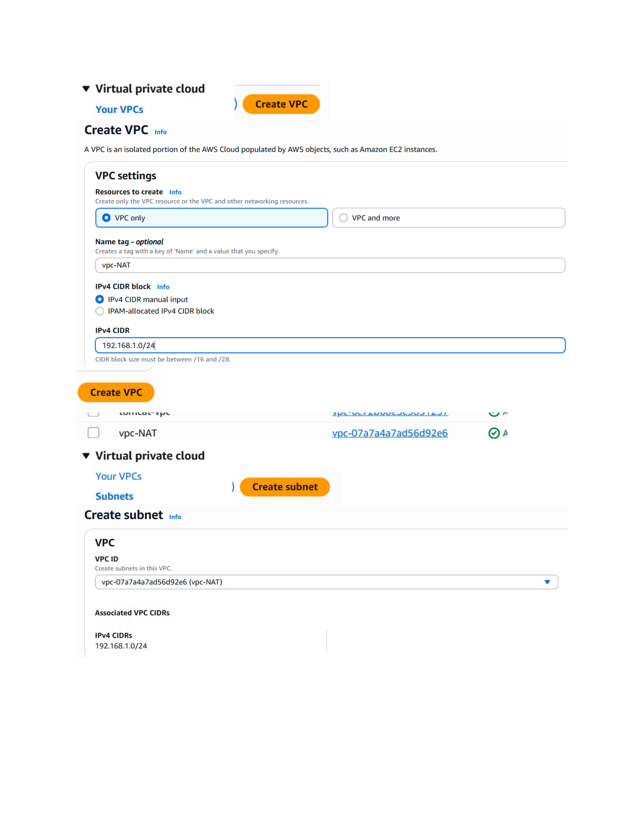
Actual action: A VPC named vpc-NAT is configured as VPC only with the IPv4 CIDR block 192.168.1.0/24, and the Create VPC action is shown.

Page 2 — Create the Public Subnet
Topic: Public subnet configuration
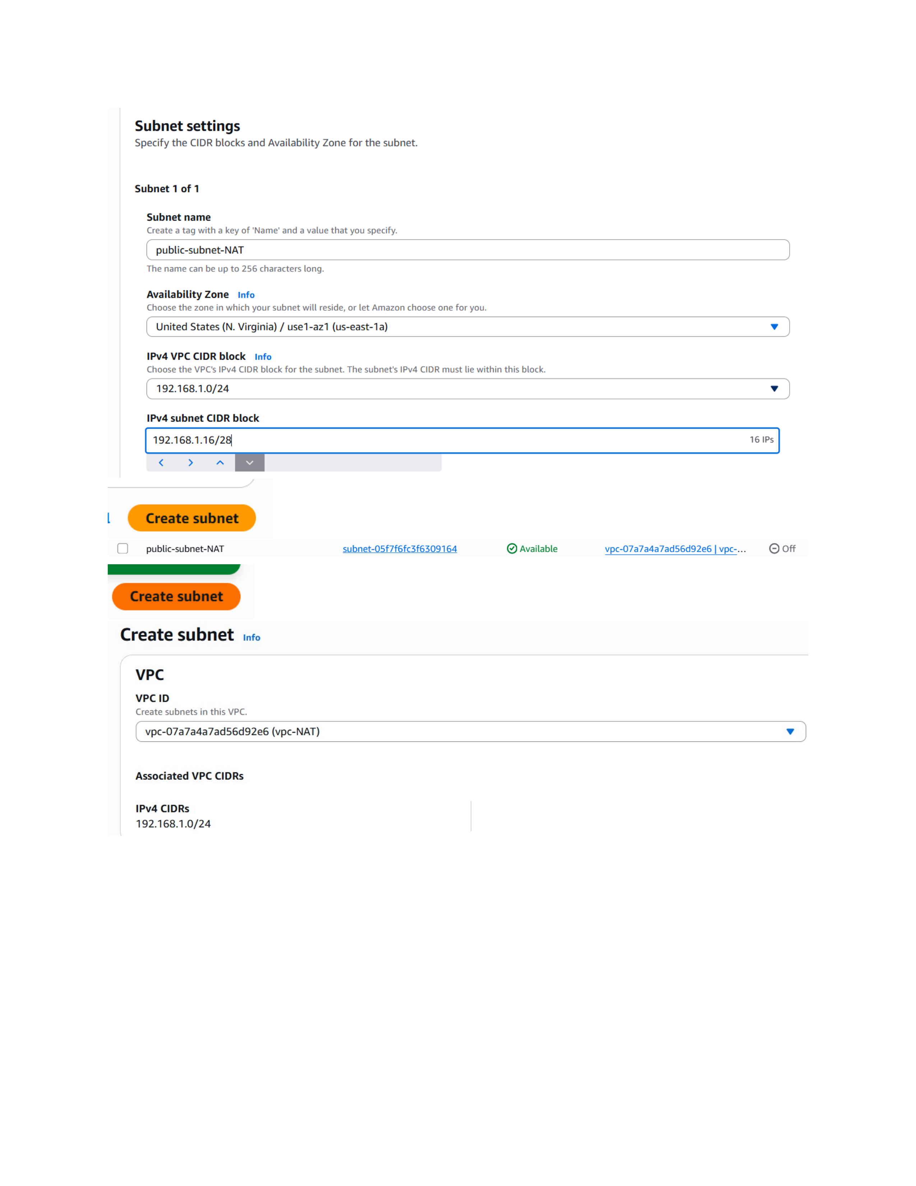
Actual action: The public-subnet-NAT subnet is configured in the VPC with the 192.168.1.16/28 subnet CIDR and the shown Availability Zone, then Create subnet is selected.

Page 3 — Create the Private Subnet
Topic: Private subnet configuration
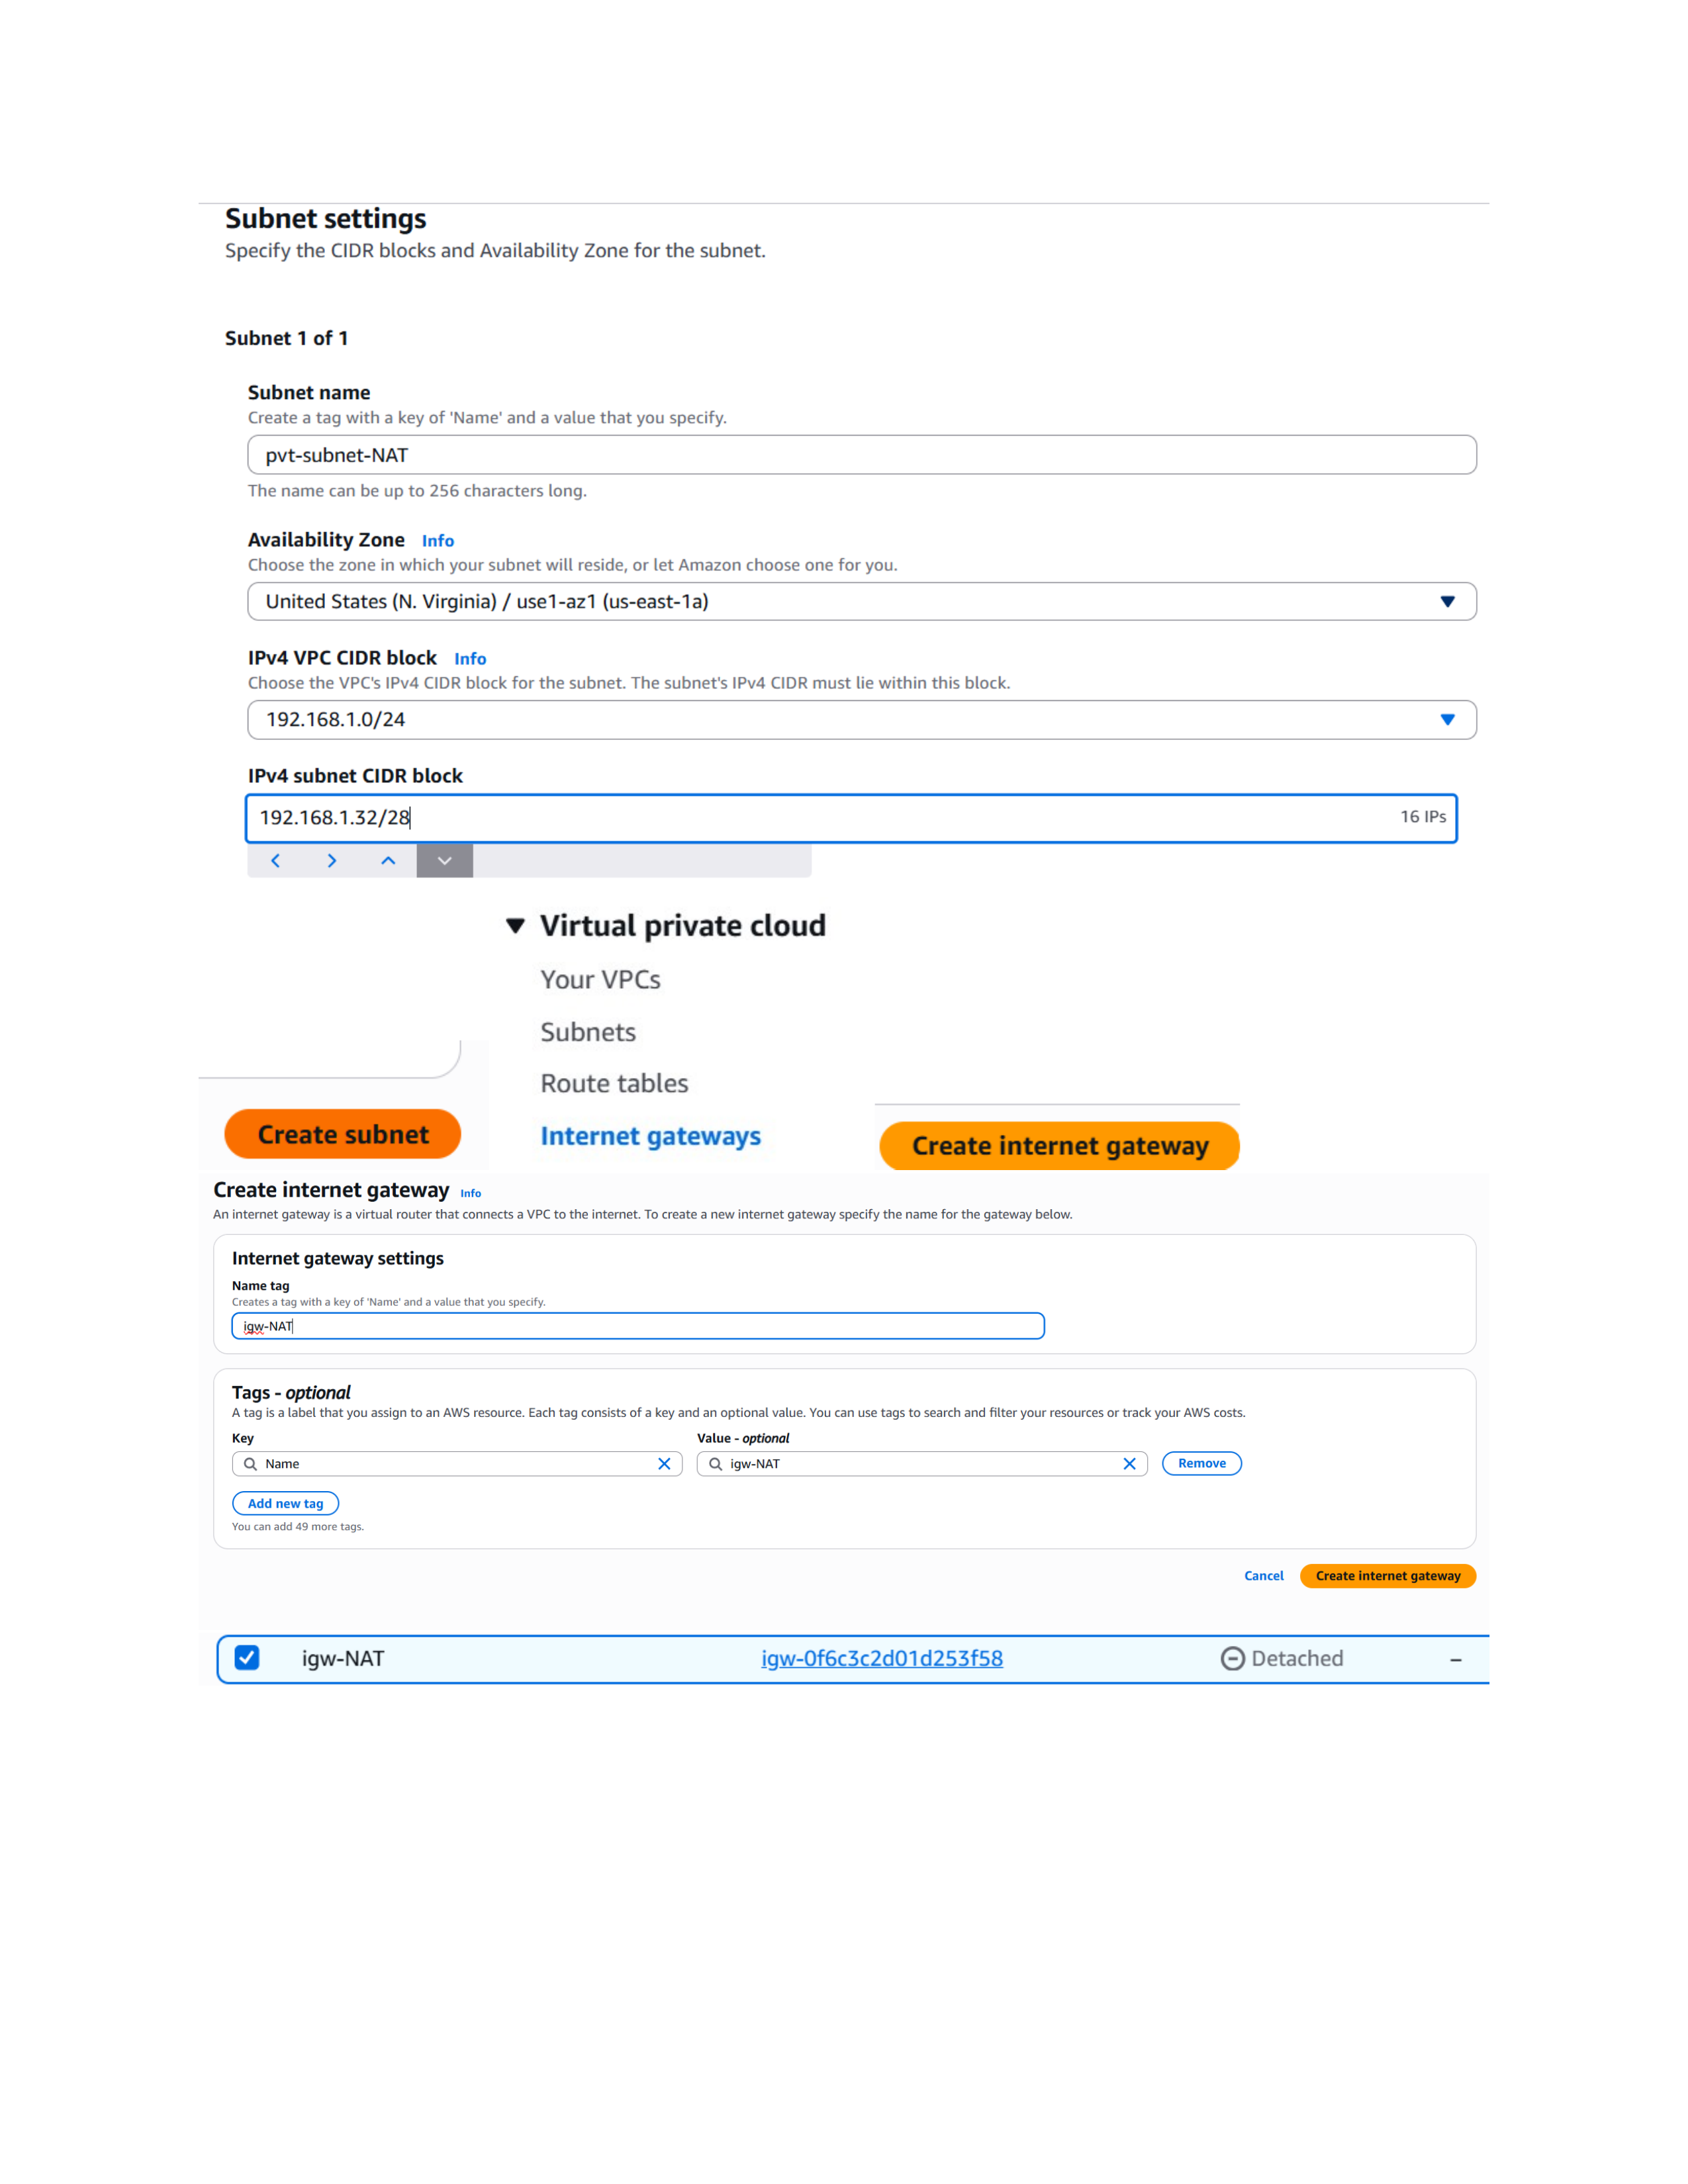
Actual action: The pvt-subnet-NAT subnet is configured in the same VPC with the private subnet CIDR and the shown Availability Zone.

Page 4 — Attach the Internet Gateway
Topic: Internet Gateway attachment
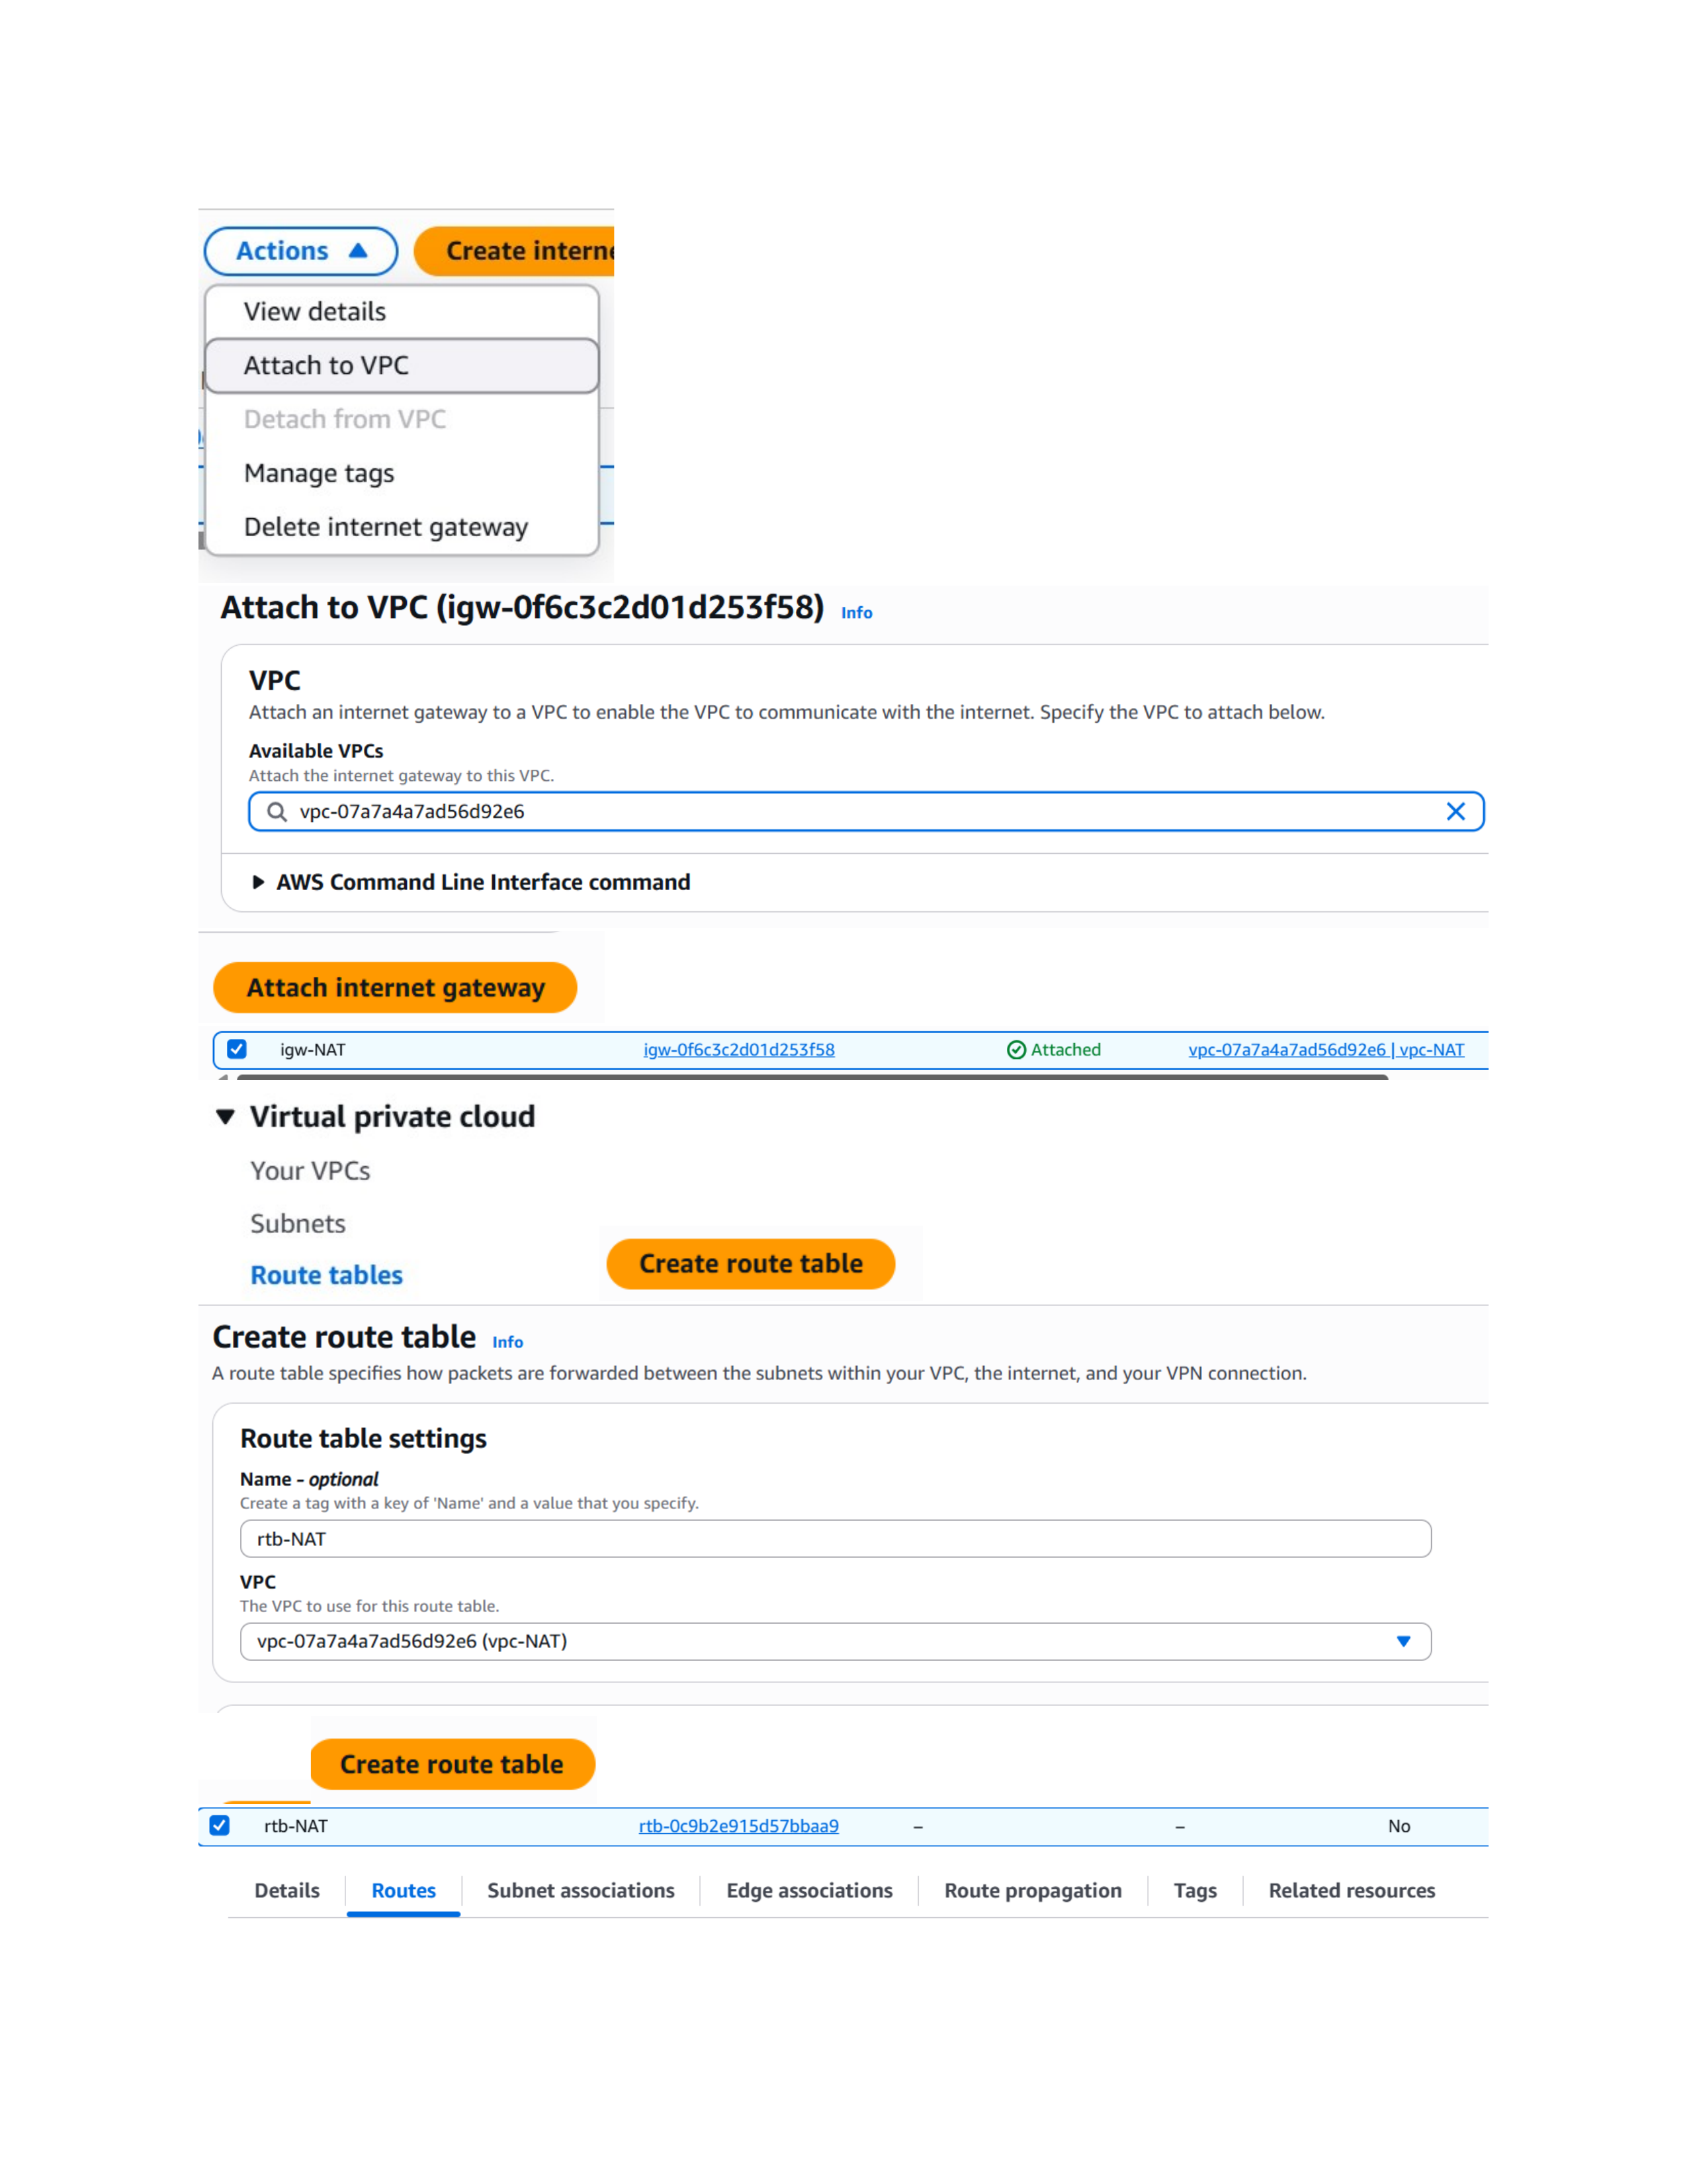
Actual action: The Internet Gateway is attached to the vpc-NAT VPC so the VPC can communicate with the internet.

Page 5 — Configure the Public Route Table
Topic: Public routing and subnet association
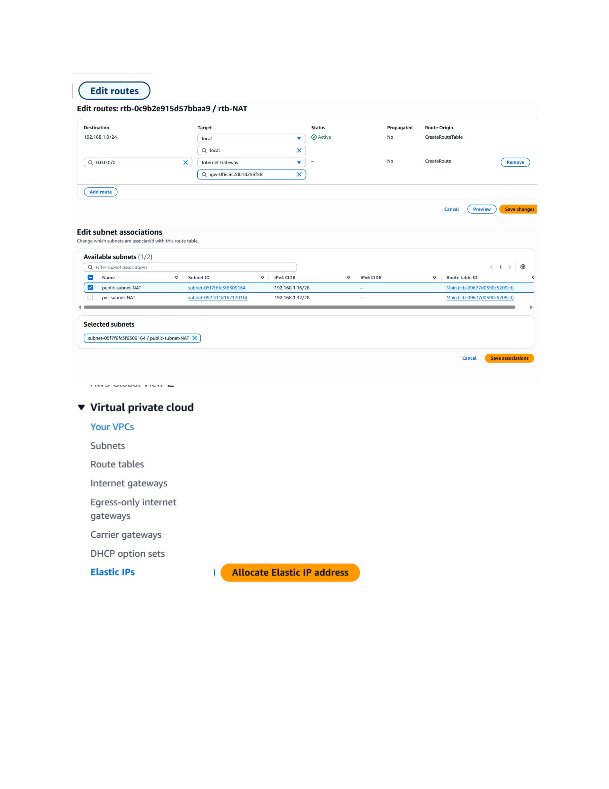
Actual action: The public route table is edited with a 0.0.0.0/0 route targeting the Internet Gateway, and subnet associations are shown.

Page 6 — Allocate an Elastic IP
Topic: Elastic IP address allocation
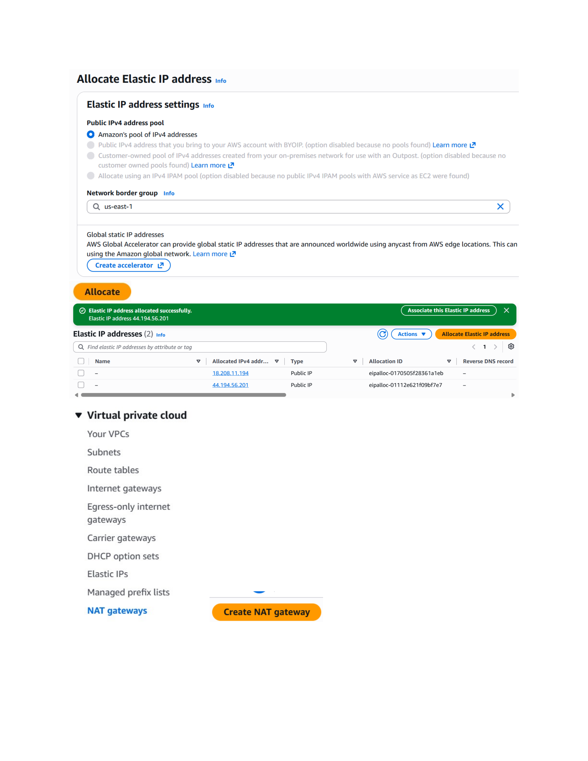
Actual action: An Elastic IP is allocated from Amazon's IPv4 address pool in the us-east-1 network border group.

Page 7 — Create the NAT Gateway
Topic: NAT Gateway configuration
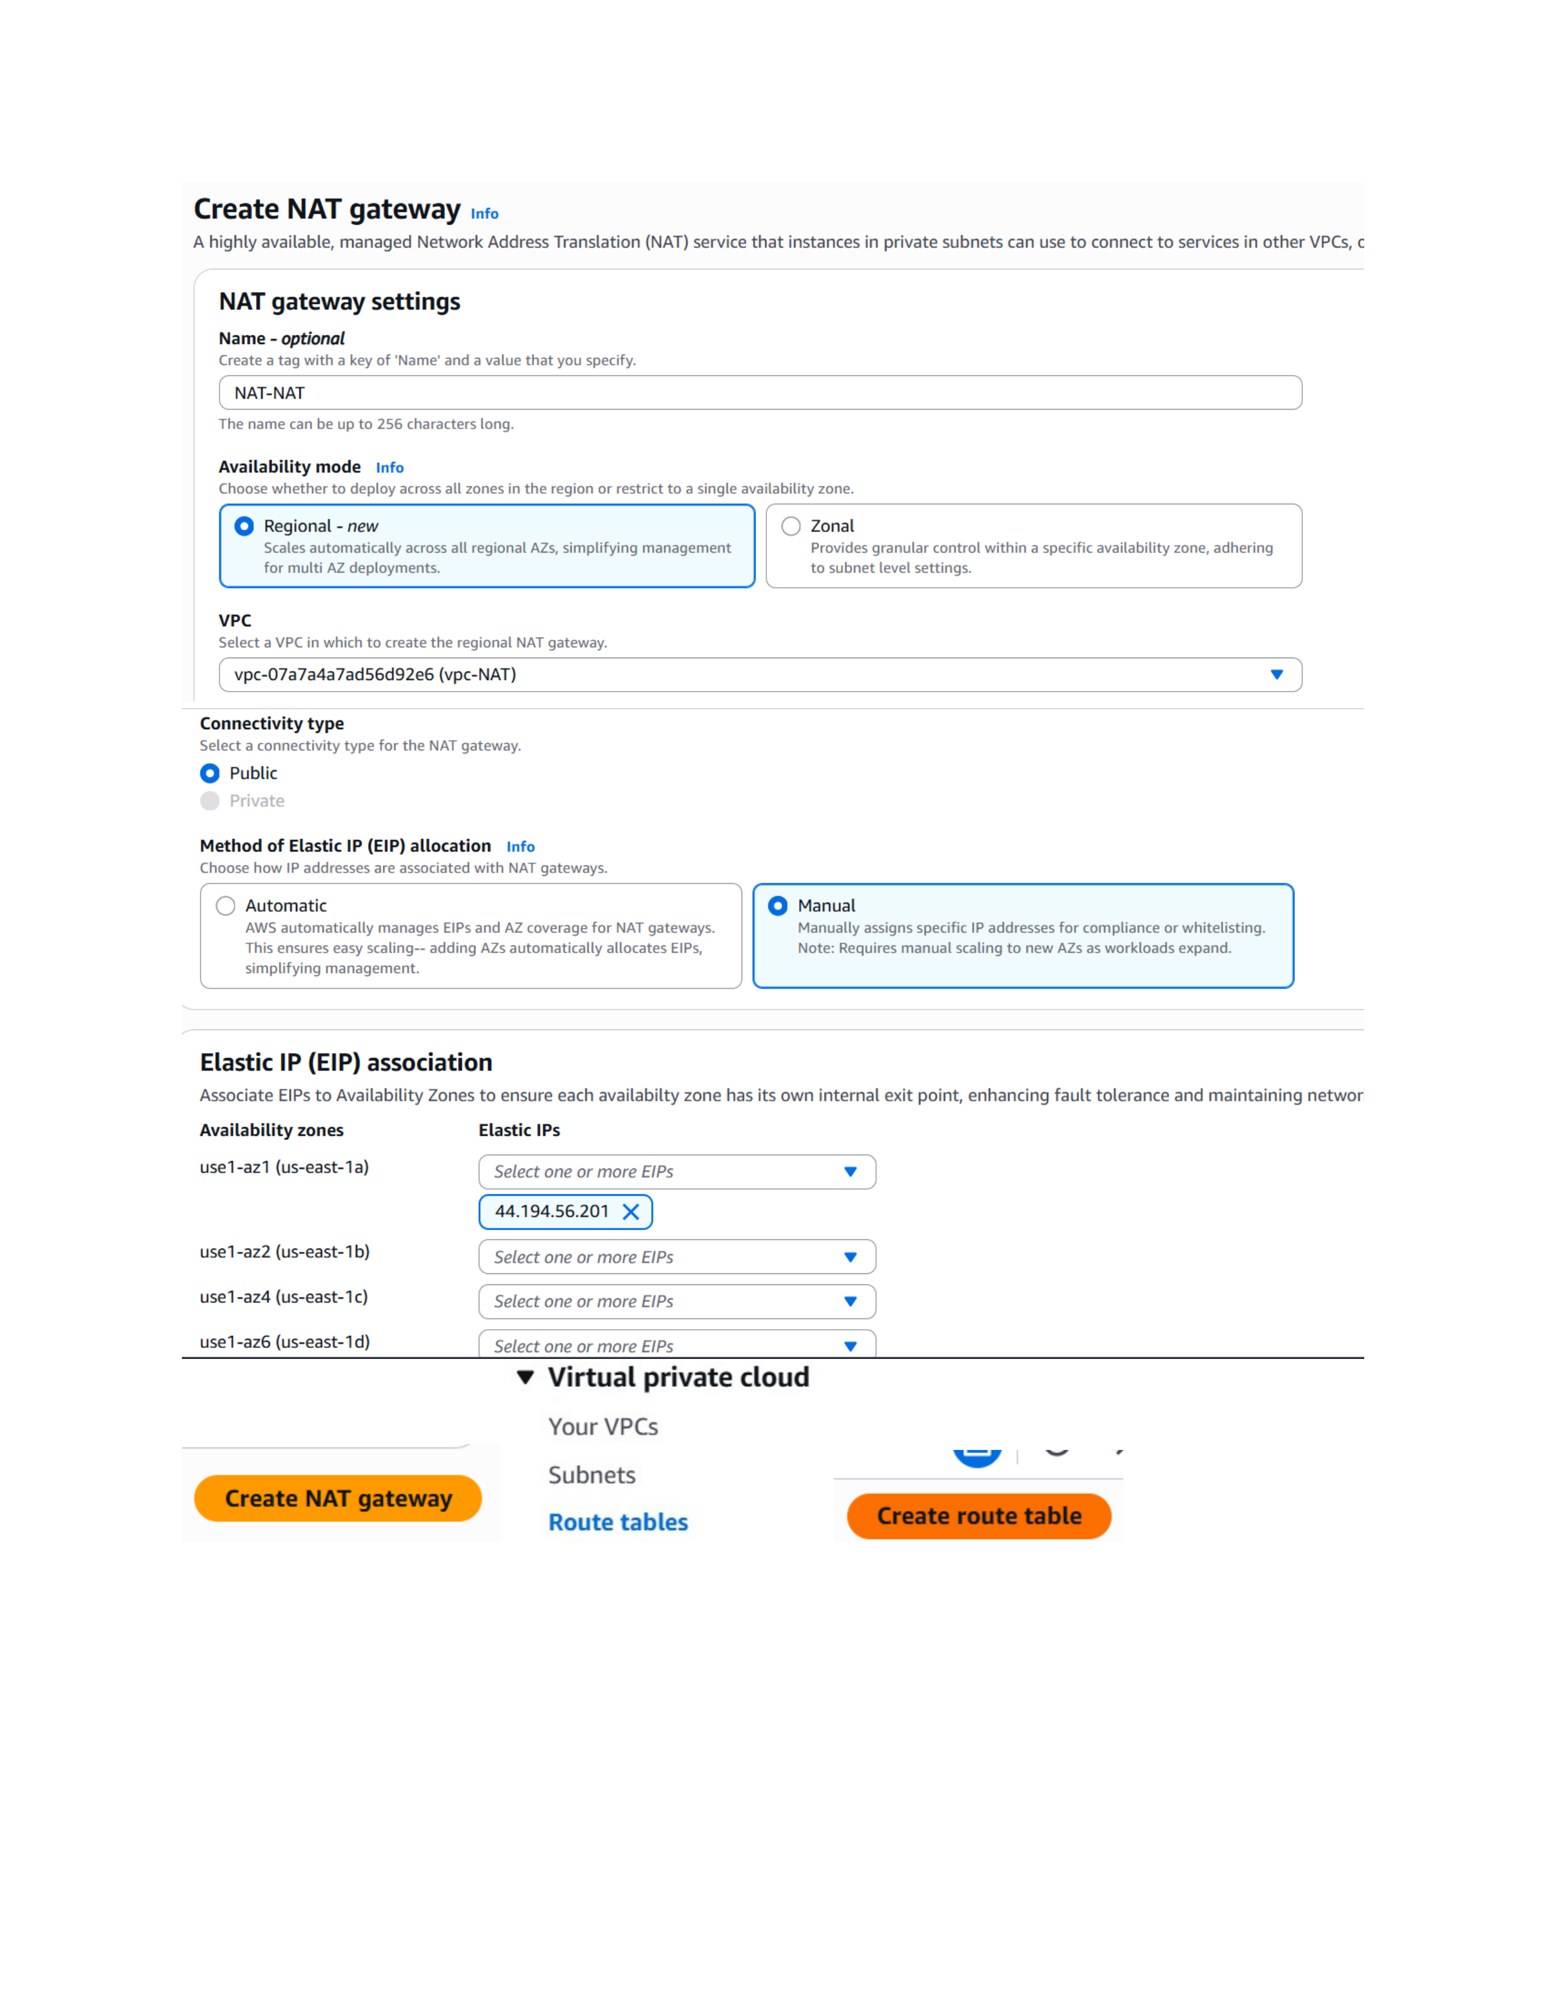
Actual action: A NAT Gateway named NAT-NAT is configured for the selected subnet, with the shown availability mode and Elastic IP settings.

Page 8 — Create the Private Route Table
Topic: Private route table creation
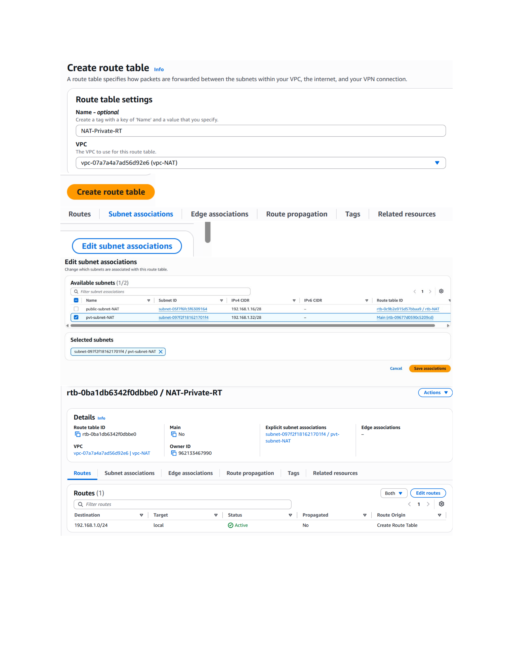
Actual action: A route table named NAT-Private-RT is created in vpc-NAT for private-subnet routing.

Page 9 — Configure the Private Route
Topic: NAT Gateway route configuration
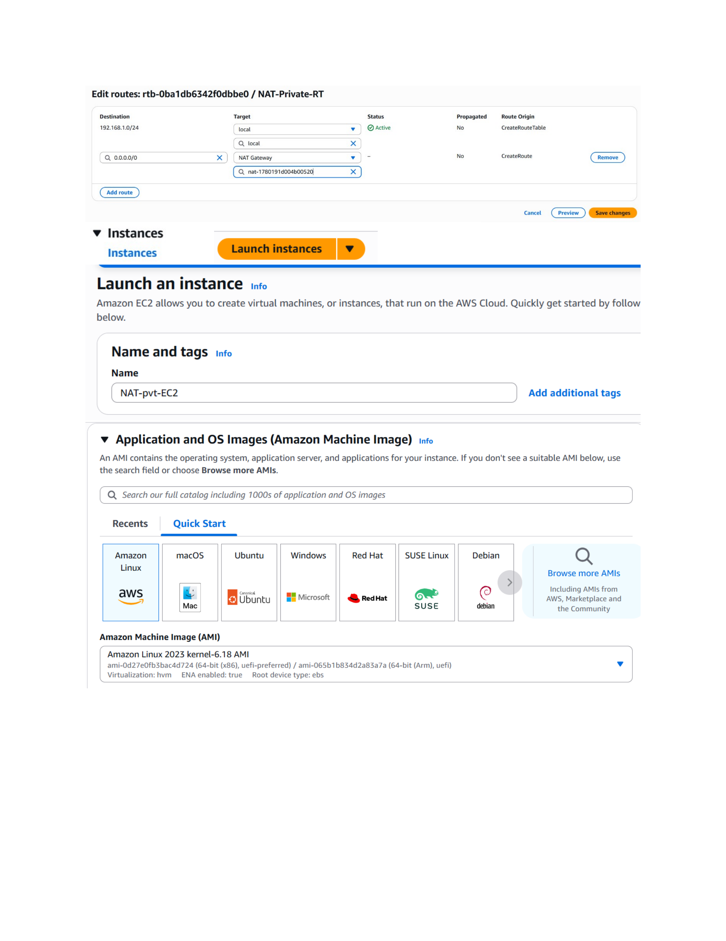
Actual action: The private route table is edited to send 0.0.0.0/0 traffic to the NAT Gateway, and the EC2 launch workflow is shown.

Page 10 — Launch an EC2 Instance
Topic: Amazon Linux EC2 instance configuration
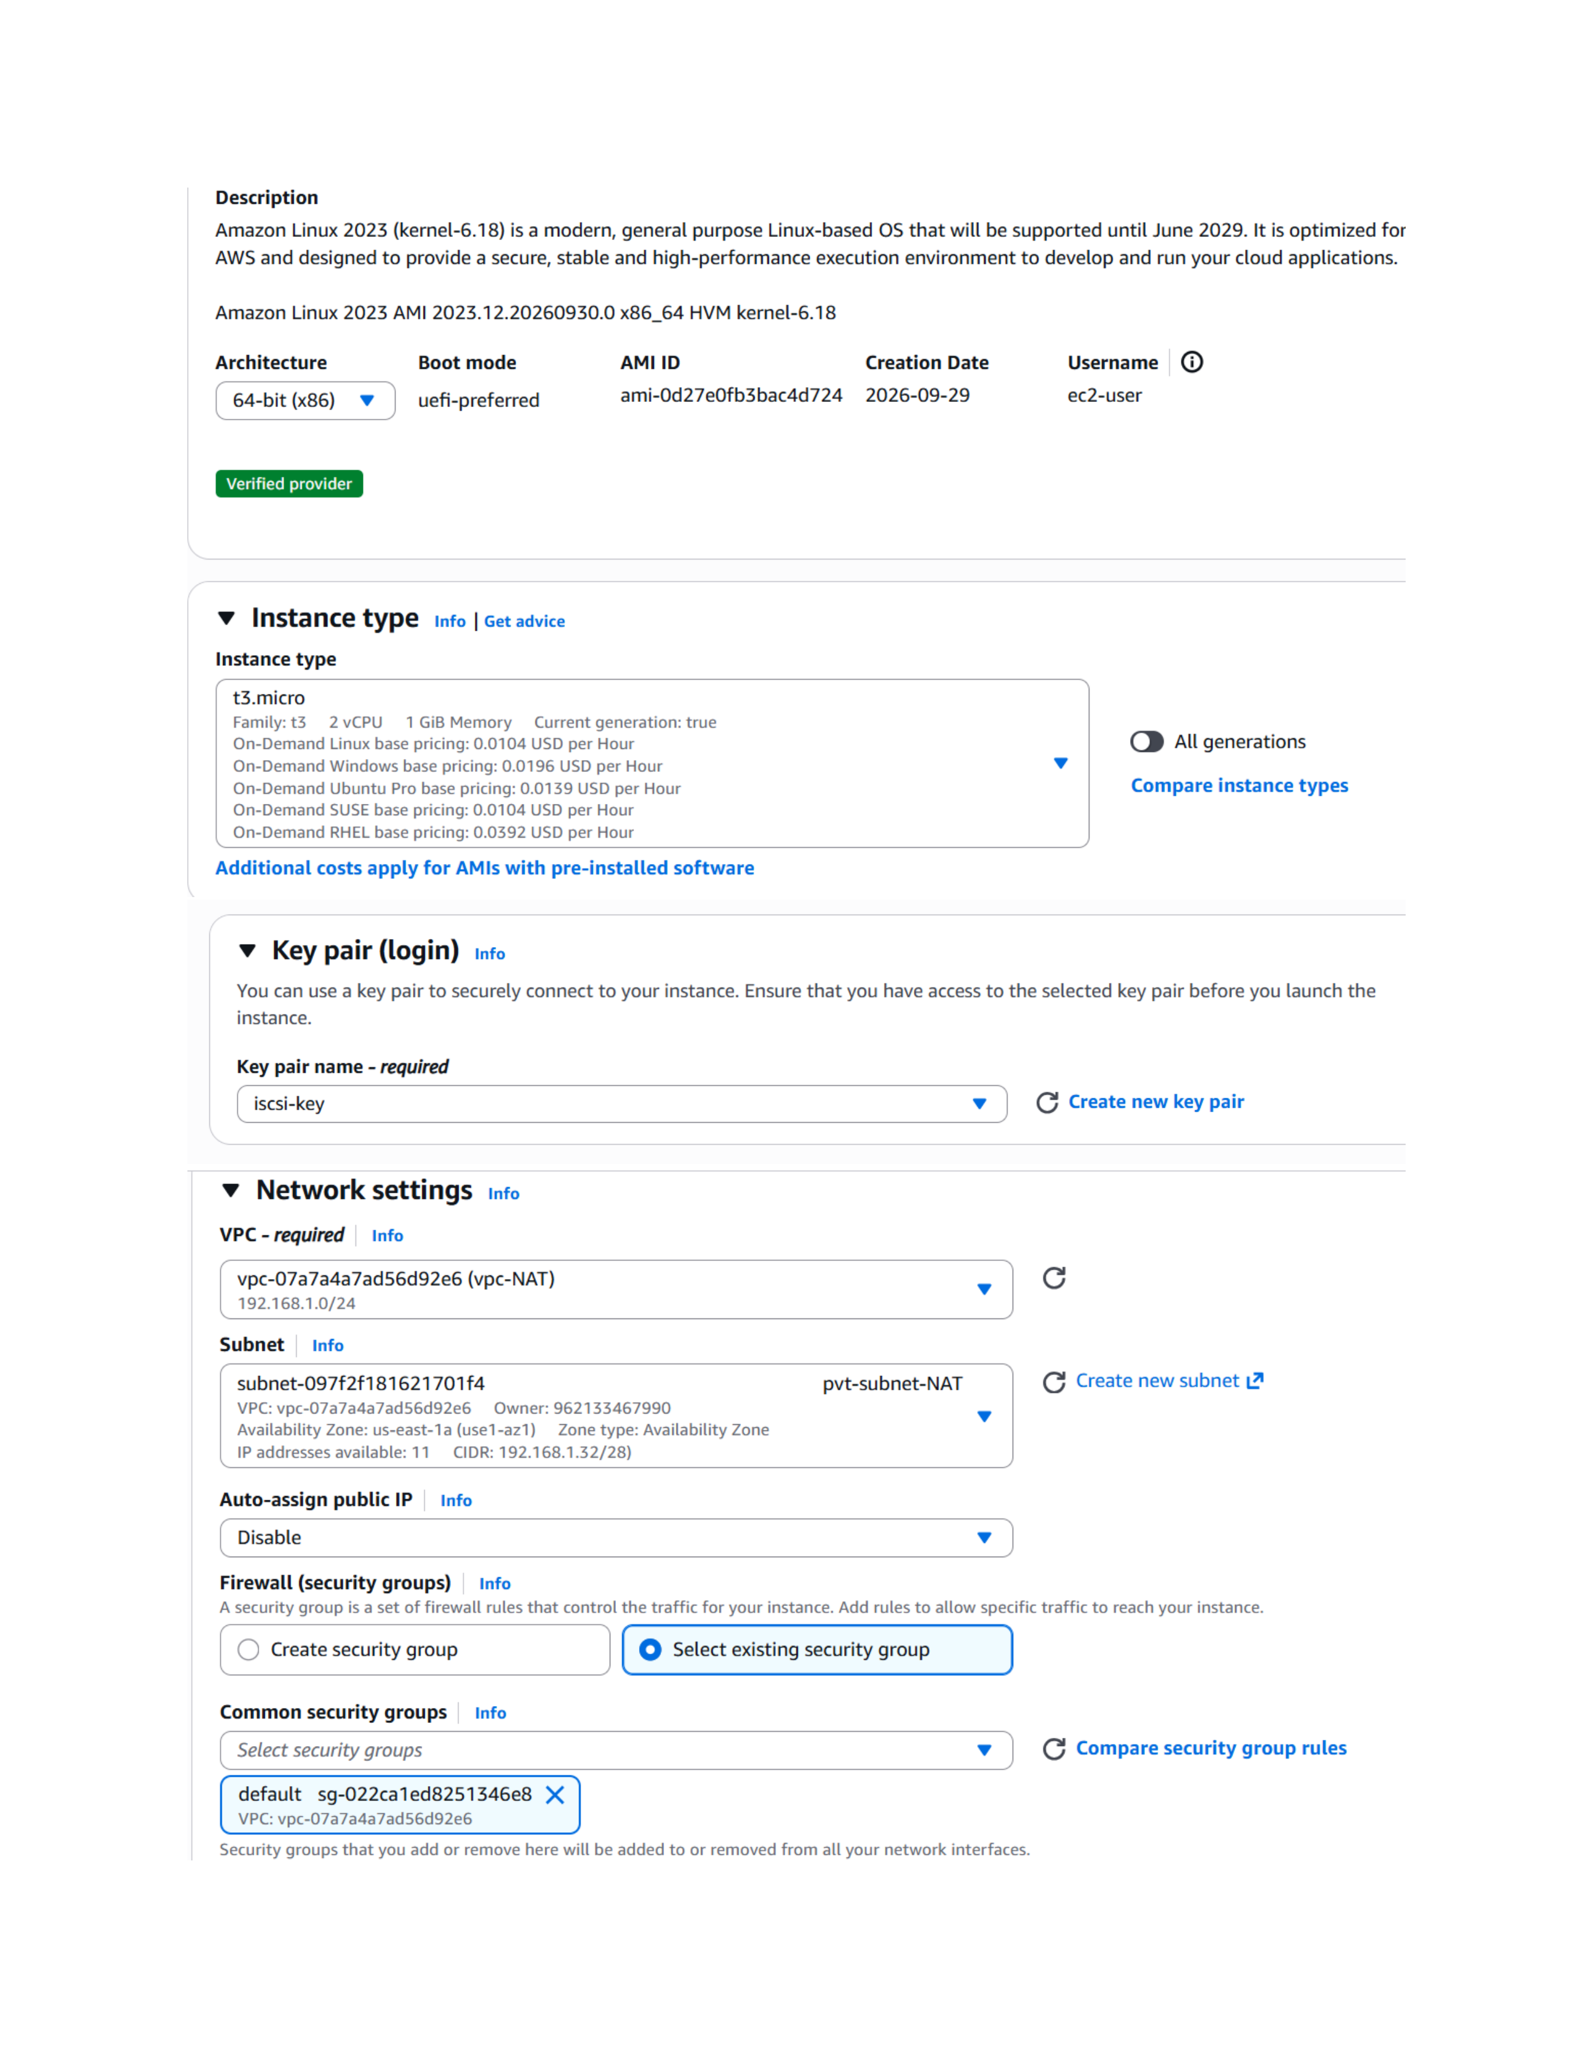
Actual action: Amazon Linux 2023 is selected as the AMI and the t3.micro instance type is selected in the EC2 launch workflow.

Page 11 — Verify the Private EC2 Instance
Topic: Private EC2 instance and security settings
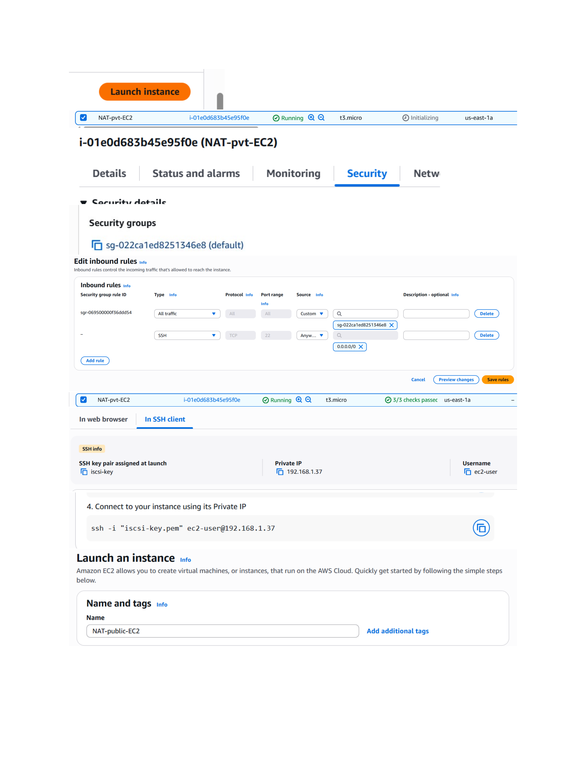
Actual action: The NAT-pvt-EC2 instance is shown running in the private environment, with its security-group details and inbound-rule controls visible.

Page 12 — Select the AMI
Topic: Application and OS image selection
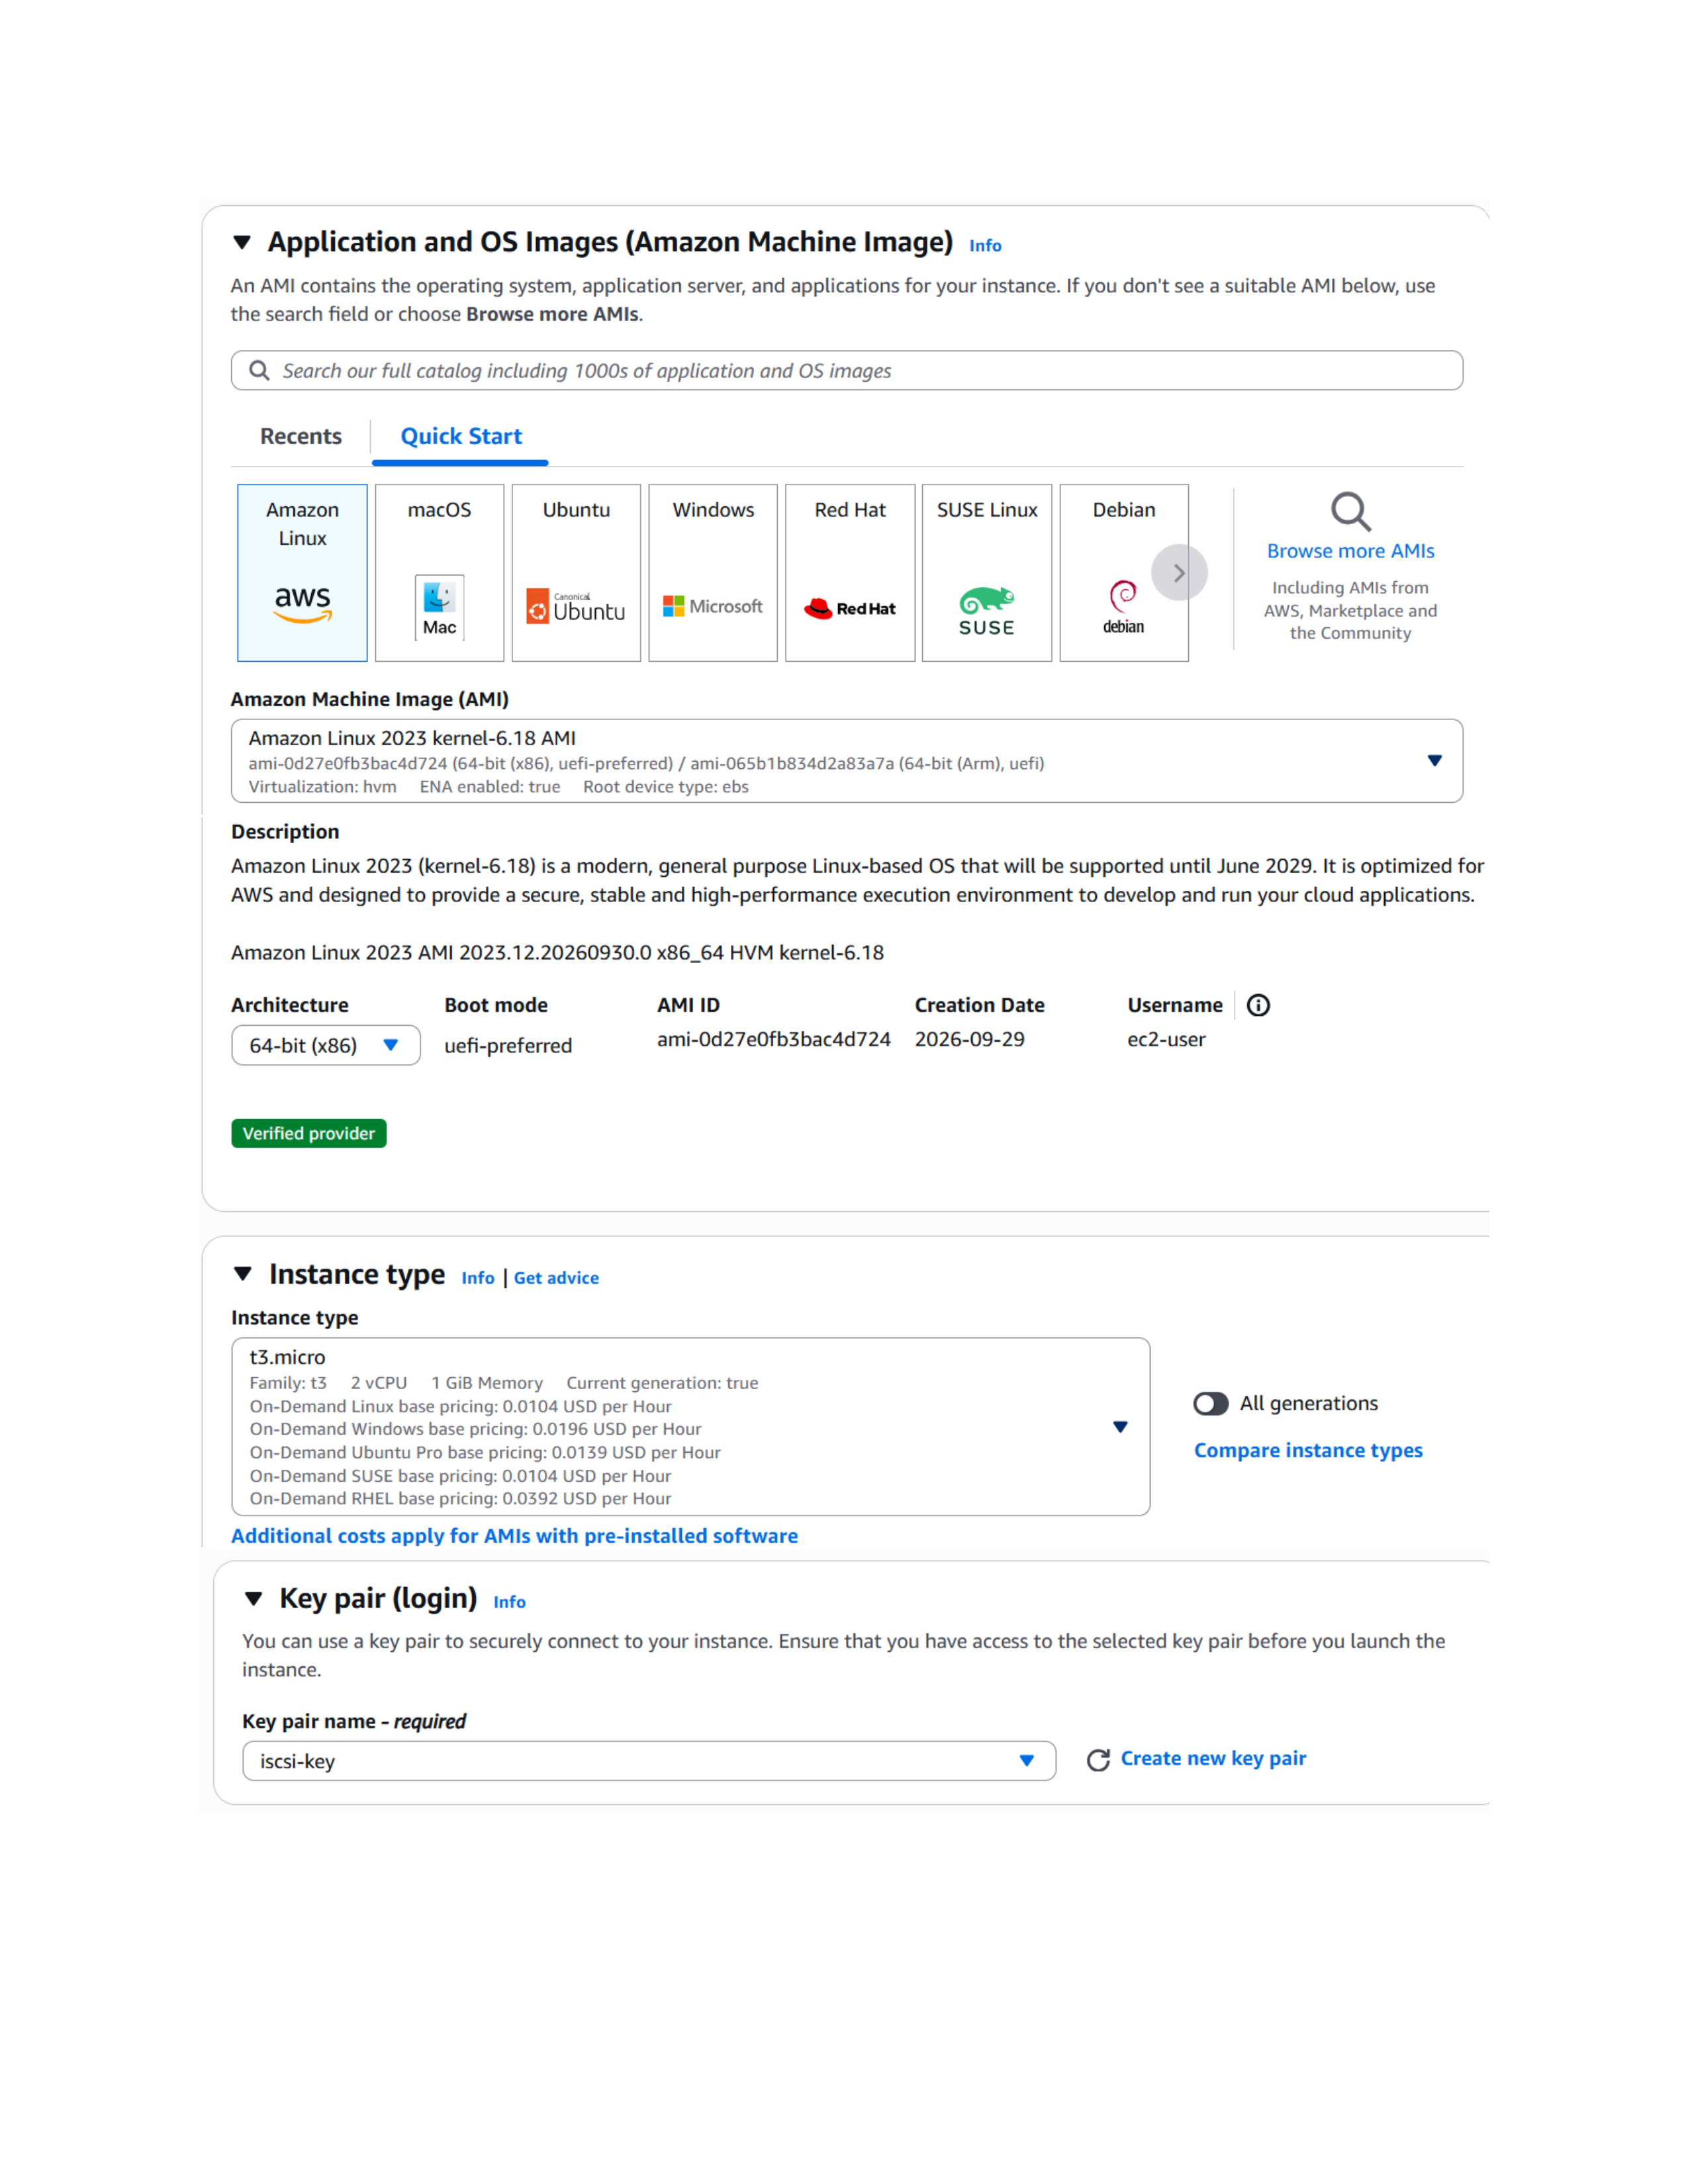
Actual action: The EC2 launch wizard's Application and OS Images section is opened and the AMI selection area is shown.

Page 13 — Configure Network Settings
Topic: VPC and subnet selection
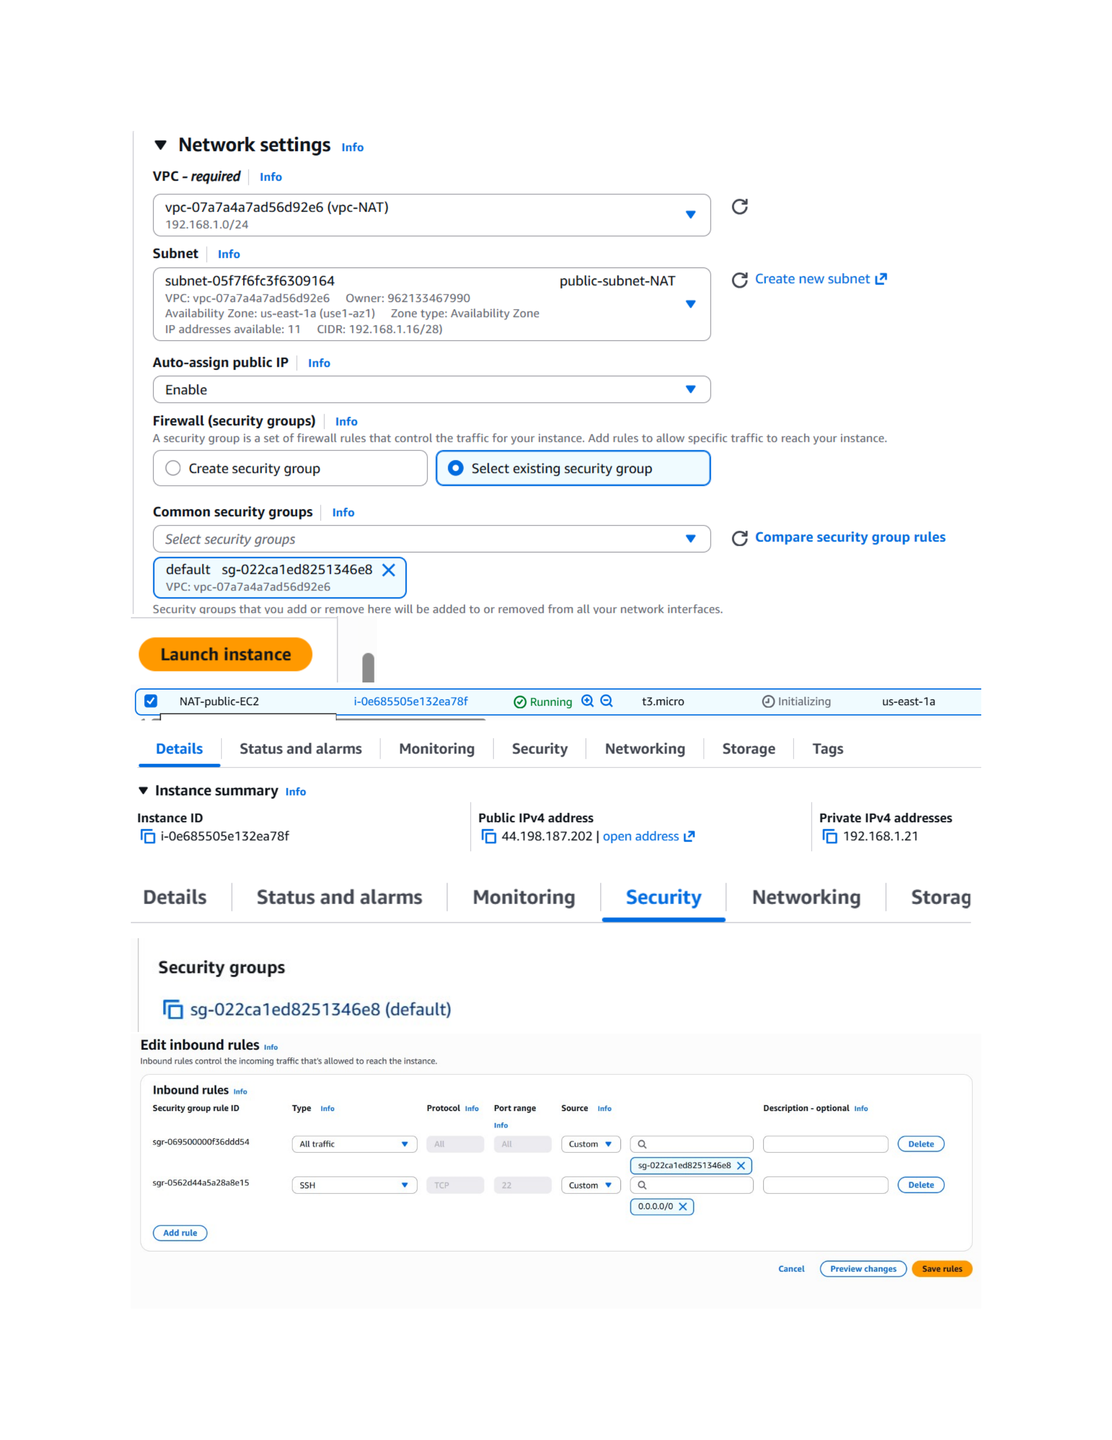
Actual action: Network settings are configured for the EC2 instance using vpc-NAT and the shown 192.168.1.0/24 VPC network.

Page 14 — Verify the Public EC2 Instance
Topic: Public EC2 instance and security settings
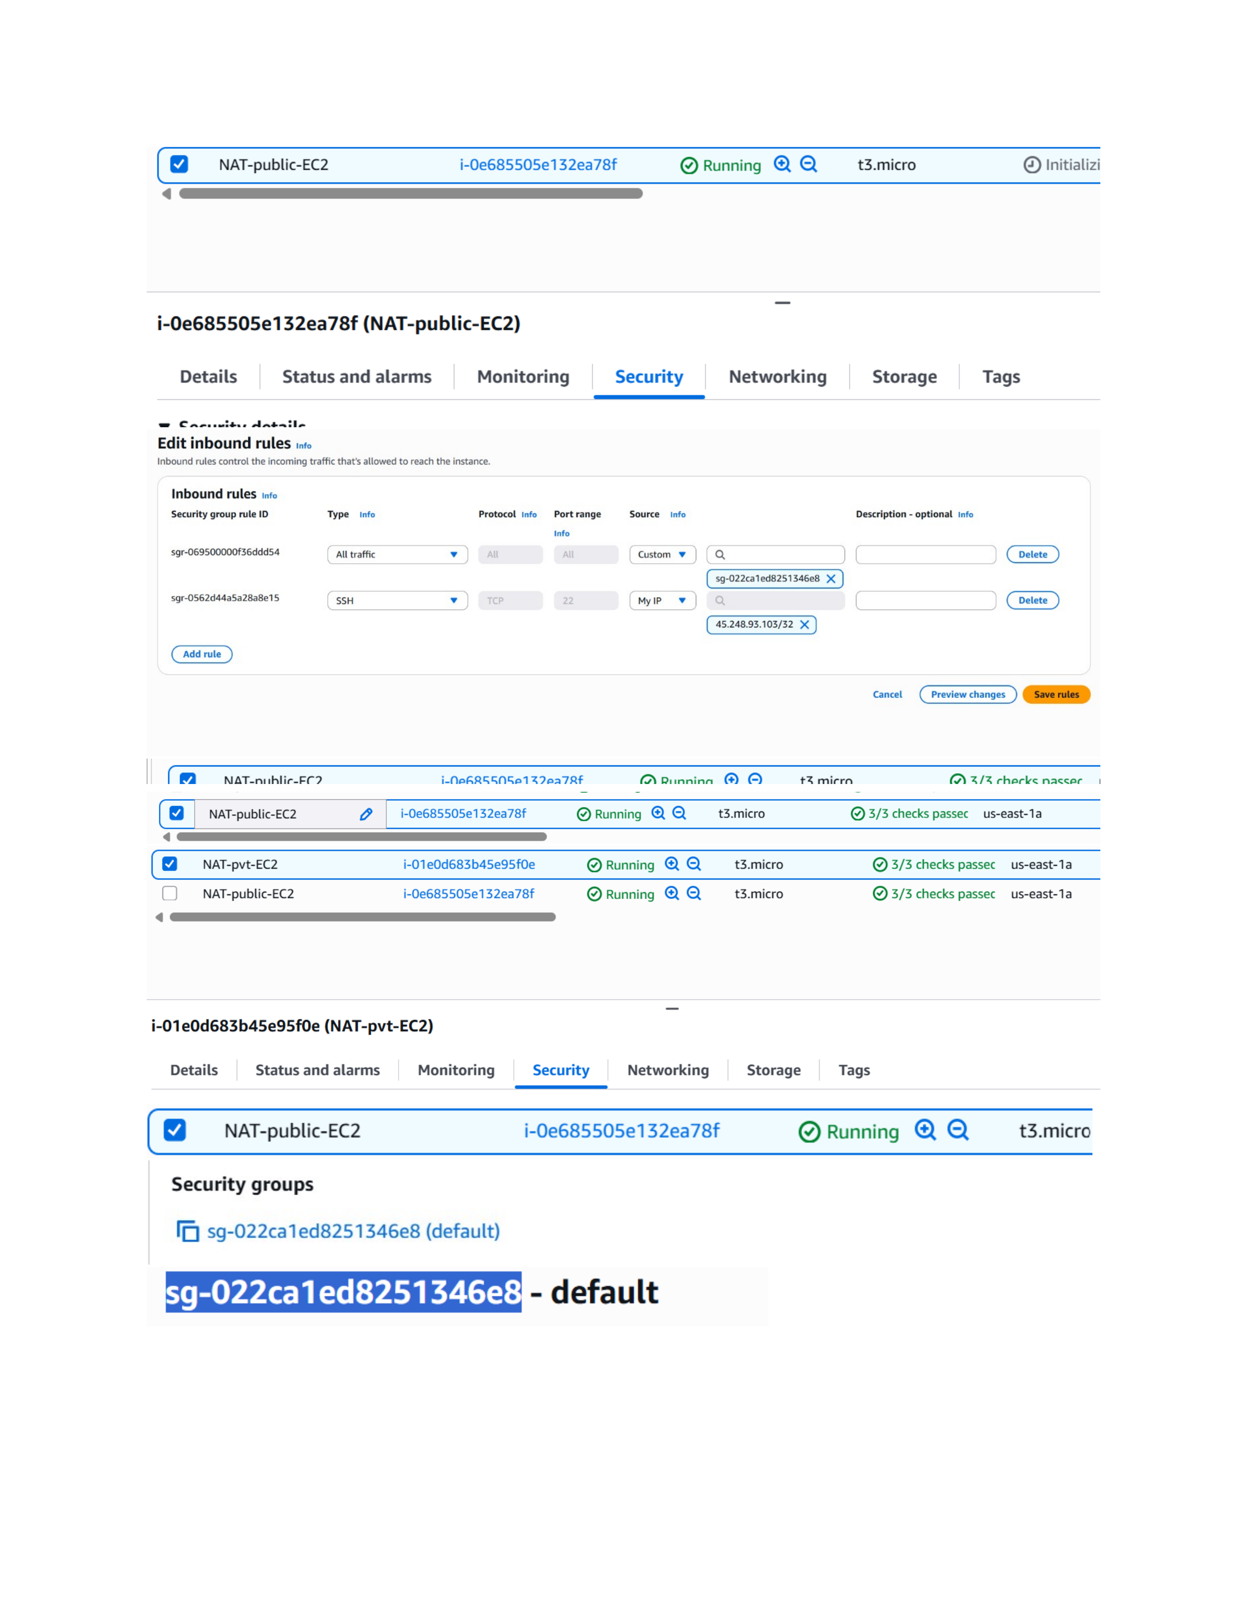
Actual action: The NAT-public-EC2 instance is shown running, with its instance details and inbound-rule controls visible.

Page 15 — Edit Inbound Rules
Topic: Security group inbound-rule configuration
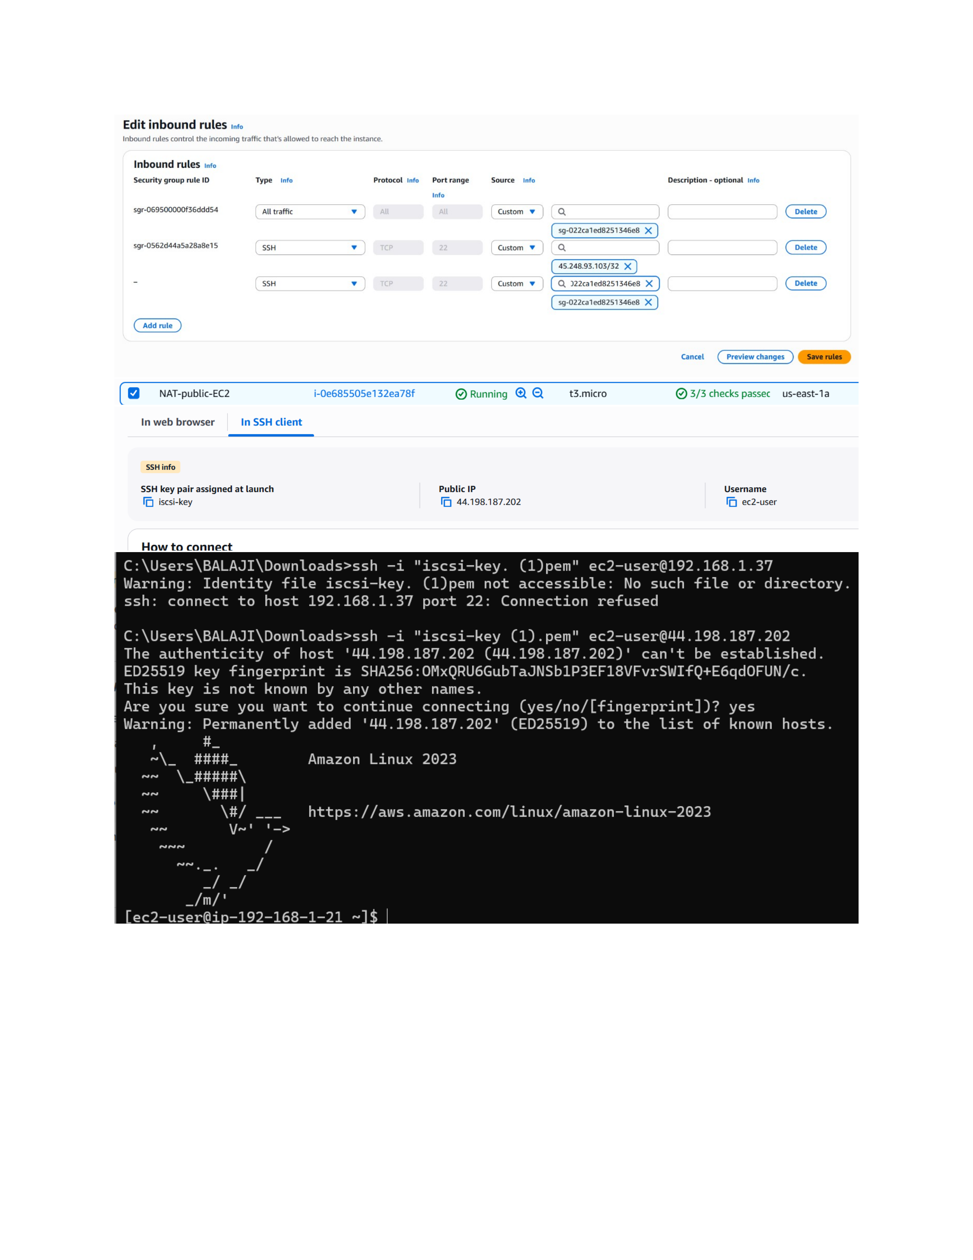
Actual action: The security group's Edit inbound rules screen is opened to configure the allowed inbound traffic, protocol, port, and source.

Page 16 — Verify Public Instance Status
Topic: Public instance health and address
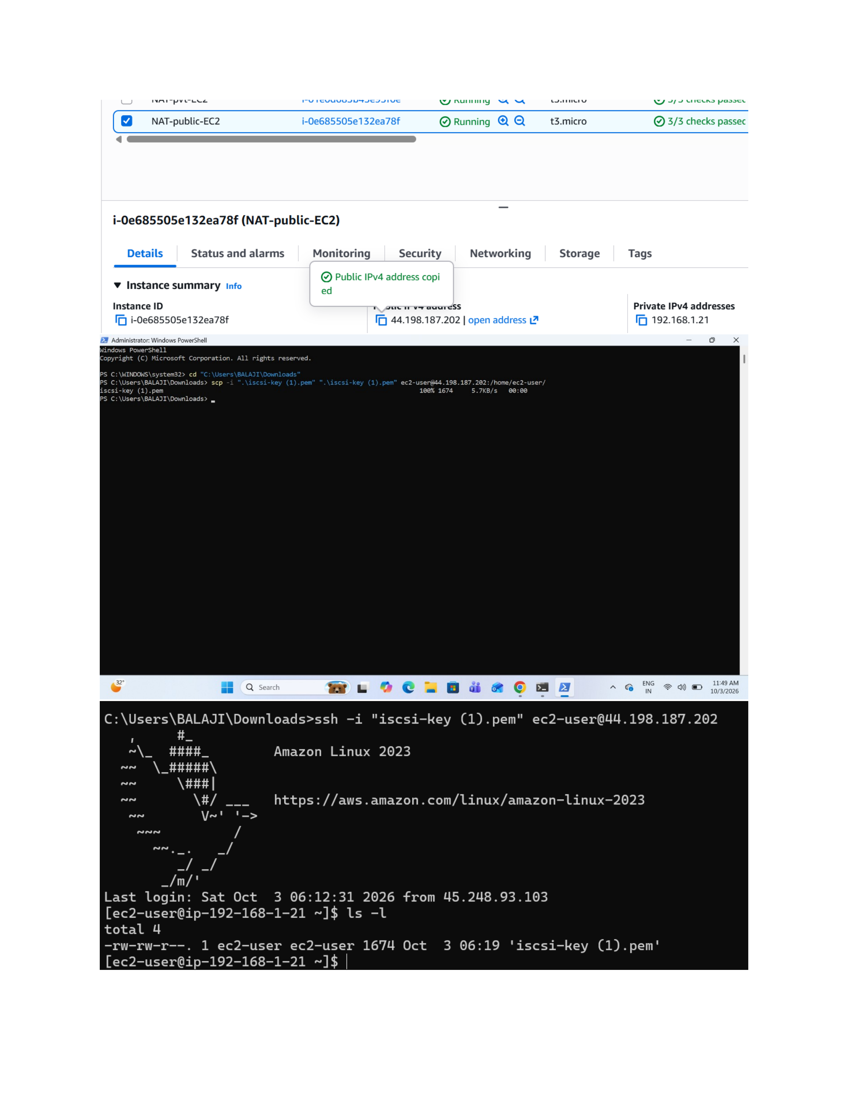
Actual action: NAT-public-EC2 is shown running with its status checks passed and its public IPv4 address area visible.

Page 17 — Verify Private Instance
Topic: Private instance status and connectivity setup
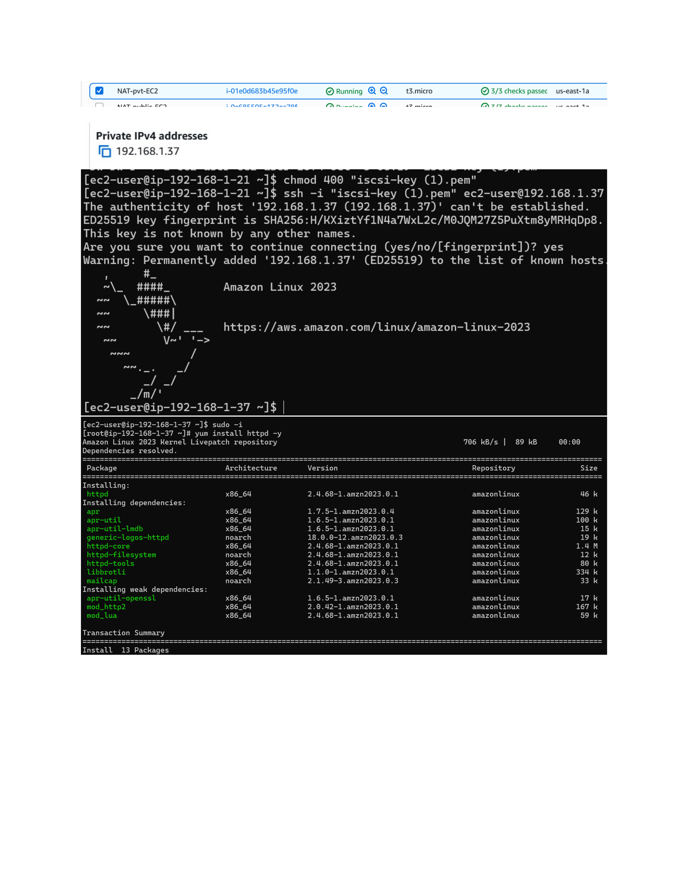
Actual action: NAT-pvt-EC2 is shown running with its status checks and private-network details visible for the NAT-based setup.

Page 18 — Review VPC Resources
Topic: Final VPC resource overview
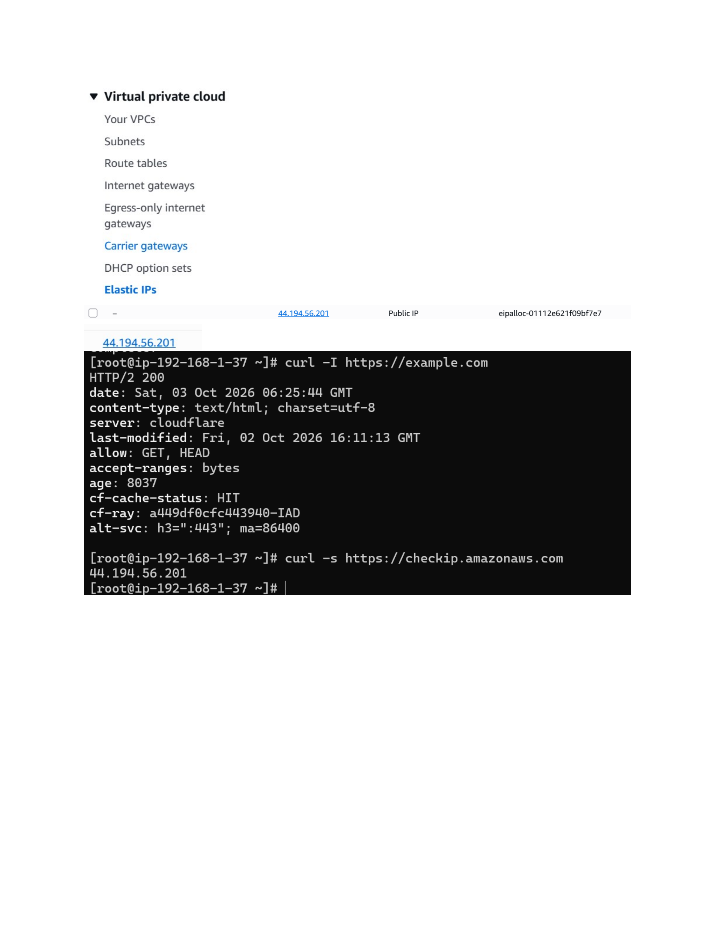
Actual action: The VPC console overview is shown with VPCs, subnets, route tables, and Internet gateways available for final verification.

